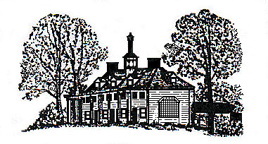
The Mount Vernon Council of Citizens’ Associations, Inc.
P.O. Box 203, Mount Vernon, VA 22121-9998 http://www.mvcca.org

July 25,2015

Chairman Sharon Bulova
Board of Supervisors, County of Fairfax
12000 Government Center Parkway, Suite 530
Fairfax, Virginia 22035-0071

Dear Chairman Bulova:
Attached for your information and requested action is Resolution MVCCA-2015-07, “Dangerous Intersection,” approved by the General Council of the Mount Vernon Council of Citizens’ Associations on July 22, 2014, pertaining to the need for turning lanes at the intersection of Main Street and Broadway in the Mount Vernon District.

We request your assistance in seeking funding from [the Governor] to facilitate timely resolution of the existing problem. Please advise if the desired action meets with your support and is feasible to be implemented.

Sincerely yours,

Josephine Doe Andrew Elder Robert E. Young
Co-Chairs of the Mount Vernon Council of Citizens’ Associations

Contact re MVCCA-2015-07: Robert Young, 703 360-9999, youngre@gmail.net

CC: Office of the Supervisor of Mount Vernon District
CC: Committee Chair
CC: Secretary
CC: Resolution Tracker, (name of person responsible)

